Sample Templates
Crafting Action Plans and Strategies

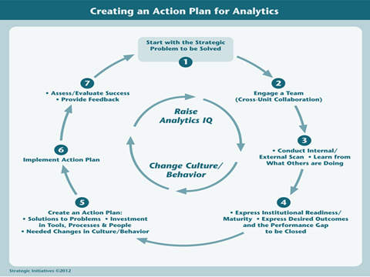

The templates on the following pages follow the steps in this graphic, plus a series of templates on turning analytics into a major change initiative on your campus.
1. Start with Strategic Problem to be Solved
Strategic Problem(s) to be Solved | Description

2. Engage a Team (Cross-Unit Collaboration Highly Desirable))
Individual/Group | Role in Analytics Planning | How to Engage in Analytics Initiative
President/Chancellor

Cabinet/Executive Team

CIO/IT Directors

Institutional Research/Institutional Effectiveness/University Planning

Academic Affairs/Student Affairs

Strategic Enrollment Management

Colleges/Academic Department – Deans, Dept Chairs, Administrators

Budget/Finance/Administration

Big Data and Analytics Expertise from Colleges

Advancement/University Relations/Communication

Others (Diversity/Affirmative Action)

External Groups – State Coordinating Boards, Others
3. Conduct an External Scan/Learn from What Others Are Doing
SWOT Analysis (Internal and External Scan) | Description
Strengths

Weaknesses

Opportunities

Threats

What Are Other Institutions Like Mine Doing? | - Check Toolkit Case Studies  - Check other EDUCAUSE Case Studies like The Change Makers
What Are Answers to FAQs About Analytics? | - Toolkit FAQs

4a. ECAR Institutional Readiness/Maturity (We have provided 4 options for item #4)
Maturity Categories | Current Score  1-----2-----3-----4----5
Culture/Process
Senior leaders who are interested in and committed to using data to make decisions
Our administration largely accepts the use of analytics
We have a culture that accepts the use of data to make decisions; we are not reliant on anecdote, precedent, or intuition
We have identified the key outcomes we are trying to improve and better use of data
We have a process for moving from what the data say to making changes and decisions
Our faculty largely accept the use of analytics
Overall Score

Data/Reporting/Tools
Our data are of the right quality and are clean
We have the right kind of data
Our data are standardized to support comparisons across areas
Reports are in the right format and show the right data to inform decisions
We have the right tools and software for analytics
Overall Score

Investment
We have an appropriate amount of funding for analytics
Funding for analytics is viewed as an investment in future outcomes rather than an incremental expense
We have an appropriate number of analysts for analytics
Overall Score

Expertise
We have IR professionals who know how to support analytics
We have dedicated professionals who have specialized analytics training
We have business professionals who know how to apply analytics to their areas
Overall Score

Governance/Infrastructure
Our information security policies and practices are sufficiently robust to safeguard the use of data for analytics
We have sufficient capacity to store, manage, and analyze increasingly large volumes of data
We have policies that specify rights and privileges regarding access to institutional and individual data
We have IT professionals who know how to support analytics
Overall Score

4b. Desired Performance Leaps for Optimizing Student Success (Using Norris/Baer Framework)
Element | Current Performance | Desired Future Performance
1. Manage the Student Pipeline

2. Eliminate the Impediments to Retention and Student Success

3. Utilize Dynamic, Predictive Analytics

4. Evolve Learner Relationship Management Systems

5. Create Personalized Learning Environments and Learning Analytics

6. Engage in Large-Scale Data Mining

Extend Student Success to Include Learning, Workforce and Life Success

4c. Desired Performance Leaps (Using Davenport/Harris Template)

Types Of Analytics, Reporting, and  Data Governance | Current Performance | Future Performance
Optimization

Predictive Modeling

Forecasting/Extrapolation

Statistical Analysis

Alerts (Real Time)

Query/Drill Down, Real Time

Ad Hoc Reports

Standard Reports

Data Governance, Data Stewardship, Data Quality

4d. Express Desired Outcomes and the Performance Gap to be Closed
(This is Very Detailed: Individual Elements Can be Selected for Detailed Treatment, Others Can Be Eliminated)
Element of Organizational Capacity | Current Capacity/Performance | Desired Future Performance
I.Technology Infrastructures, Solutions, and Services

a. Sources of Data

Administrative ERP (Student, Fin Aid, Human Resources, Financials, Alumni/Donor, Grants, Management, Procurement)

Academic Systems (Learning Management System, Learner Relationship Management System, Personalized Learning System, Special Systems for Continuing Education, Portfolio, Gradebook, Assessments/Surveys, Content Management, Library)

Transaction Systems (Facilities Management, Parking Management, Food Service, Student/Security Card, Procurement, Grants Management, Scheduling)

External Data Sources (State and Federal sources, peer institutions, open learners, other sources of assessment/certification)

b. Data, Information, Analytics Capabilities

Elements of Analytic Applications (Reporting, ETL, DW/OLAP, BI) embedded in particular systems or standalone

Extensibility and Scalability of Data in Warehouses

Query And Analysis Capabilities (Eight Elements of Davenport Typology)
Optimization
Predictive Modeling
Forecasting/Extrapolation
Statistical Analysis
Alerts (Real Time)
Query/Drlll Down (Real Time)
As Hoc Reports (Real Time)
Standard Reports (Real Time)

c. Data Stewardship and Management

Data Dictionary
Data Stewardship/Data Governance
Data Quality

4d. Express Desired Outcomes and the Performance Gap to be Closed (Continued)
Element of Organizational Capacity | Current Capacity/Performance | Desired Capacity/Performance
II. Policies, Processes, Practices

a. Policies Supporting Data, Information and Analytics, FIRPA, Others

b. Current Processes and Practices Supporting Student Success
Manage the Student Pipeline
Eliminate Impediments to Retention and Success
Utilize Dynamic, Predictive Analytics to Respond to At-Risk Behavior
Evolve Learner Relationship Management Systems
Create Personalized Learning and Learning Analytics
Engage in Large-Scale Data Mining
Extend Student Success to Include Learning, Workforce and Life Success

C, Other Processes Important to Student Success – how are data and analytics used?
Strategic Planning (Information rich?)
Institutional accountability and evidence-based decision making through
metrics, and dash boarding
Alignment of analytics planning to other core planning/accountability
Processes (Strategic Planning, Budget/Resource Allocation,
Accreditation/Program Review, Institutional Effectiveness)

III. Values and Skills of Executive Leadership/Middle Managers/Staff/Faculty

a. Analytics IQ” and Developed/Trained skills in use of analytics
Executive leadership
Middle managers
Rank and File Faculty and Staff
Power Users

b. Who Are the” Power Users?” Power users are highly skilled users who must master rules and techniques with BI tools and analytics to use them.

c. Do you have “Analytics for the masses?” Data and analytics access that are user obvious and available? What do you need?

d. Are Data, Reporting, and Analytics used pervasively by executive leadership?
4d. Express Desired Outcomes and the Performance Gap to be Closed (Continued)
Elements of Organizational Capacity for Analytics | Current Condition | Desired Future Condition
IV. Describe Your Organizational Culture Regarding Data and Analytics

a. Basic use of data

b. Culture of Reporting Evidence-based Decision Making Performance Measurement and Improvement

c. Decision-Making Behaviors of Institutional Leadership and Student Success behaviors of front-line faculty and staff

V. Leadership

a. Leadership involvement and commitment to analytics and student success

b. Level of active engagement

c. Level of resources made available to data, reporting, analytics
Infrastructure and tools, processes and policies, analytics staff

VI, Capacity for Collaboration, Sharing, Partnership
a. What are your collaborations with technology providers, other institutions, federated solutions?

b. Do you utilize Hosted solutions, shared solutions? Have you considered in-the-cloud services?

5. Develop Action Plan

Elements | Description/Metrics/Targets
Solutions to Problems/Initiatives

1.

2.

3.

4.

5.

Investments in Tools, Processes and People

Desired Changes in Culture/Behaviors

6. Implement Action Plan
Initiatives/Actions | Implementation Efforts | Timeline and Responsibilities
1.

2.

3.

4.

5.

Investments

Behavior/Culture Changes

7. Assess/Evaluate Success/Feedback

Initiatives/Actions | Assessment/Metrics | Evaluate Success and Feedback
1.

2.

3.

4.

5.

Investments

Behavior/Culture Changes

Overall: Build Analytics IQ/Change Organizational Culture

Actions/Options | Project Plan & Launch | Year 1 | Year 2-3
1. Off-campus Training through Professional Association (EDUCAUSE, AASCU, AACC)

2. Campus Symposium/Retreat on Analytics/Student Success
3. Campus Workshops/Webinars based on Toolkit Resources

4. Online Community of Practice on Student Success

5. Develop Strategy for Leveraging Analytics, Aligned with University Strategies

6. Early Win Projects, Demonstrable Outcomes from Changed Behaviors

7. Benchmarking Against Leading Institutions

8. Demonstrate ROI from Investing in Analytics to Support Student Success

9. Augment Existing Talent Pool through Partnerships with Solution Providers, Federated Solutions, Collaborations, Consultations

Prelude to Developing Strategy:
Engage Team and Articulate Leveraging Analytics as a Major Change Strategy

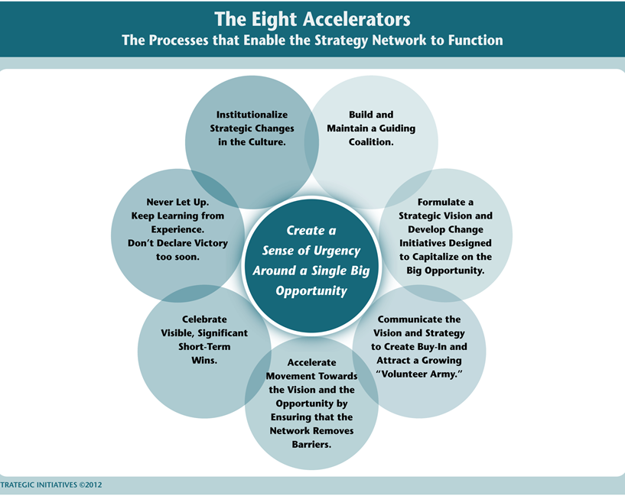

Leveraging Analytics as a Major Strategy

Step/Stage | Description
Establish a Sense of Urgency Around Analytics

- Identify market and competitive realities

- Identify and discuss crises, real and potential, and major opportunities
Form a Powerful Guiding Coalition Around Analytics

- Assemble a group with enough power to lead the change effort
- Encourage the group to work together as a team

Create a Vision for Leveraging Analytics to Optimize Student Success
- Create a vision to help direct the change effort
- Develop the strategies for achieving that vision

Communicate the Vision
- Use every vehicle possible to communicate the vision
- Develop Communication and Engagement Plans
- Change the systems and structures that seriously undermine the vision
- Encourage risk-taking, nontraditional ideas, activities and actions

Leveraging Analytics as a Major Strategy (Continued)
Step/Stage | Description
Empower Others to Act on That Vision

- Get rid of obstacles
- Change systems or structures that seriously undermine the vision

Plan for and Create Short-Term Wins

- Plan for visible performance improvements
- Create those improvements
- Recognize and reward employees involved in those improvements

Consolidate Improvements and Produce Still More Changes

- Use increased credibility to change systems, structure, and policfies that don’t fit the vision
- Hiring, developing, and promoting employees who can implement this vision
- Reinvigorate the process with new projects, themes, and change agents

Institutionalize New Approaches, Embed in the Culture

- Articulate the connections between the new behaviors and institutional success
- Develop the means to ensure leadership development and succession

