- BLUEPRINT your session -
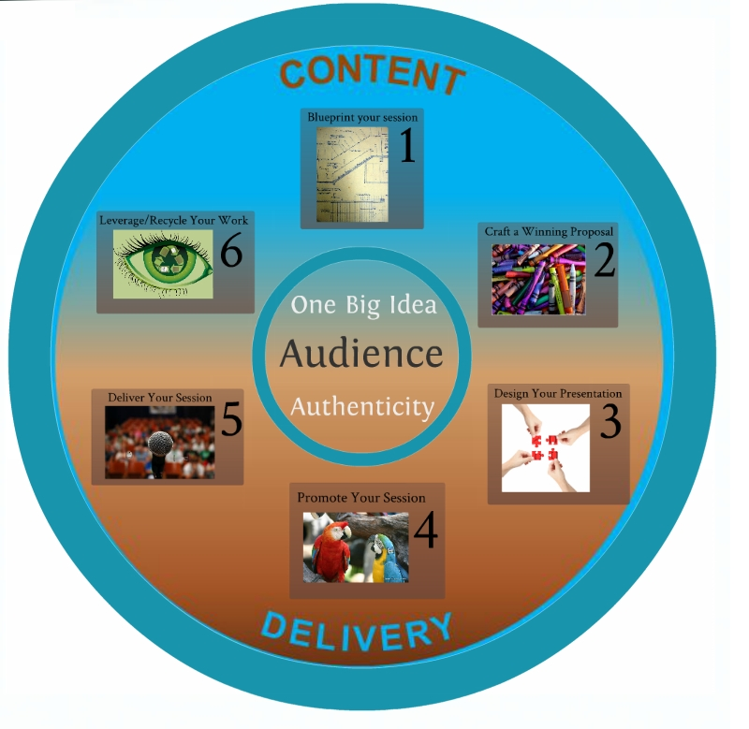
  - Define your AUDIENCE
  - Define your ONE BIG IDEA
  - This shapes your objective(s) and keeps your focus
  - Get it down to one sentence
  - Keep it AUTHENTIC!
  - Resources:
  - Create a Presentation Your Audience Will Care About (by Nancy Duarte)

- Craft a Winning Proposal
  - Research the CFP
  - Clearly connect your ONE BIG IDEA to the conference theme and specific track
  - Keep your AUDIENCE in mind
  - Make your title accurate and catchy
  - Make your abstract clear and intriguing
  - Define 3-5 focused learning objectives
  - Use your own voice/style – keep it AUTHENTIC!
  - Resources:
  - Article Title Generator tool
  - Jeff Hurt Blog: How to write killer conference session titles that attract attendees
  - Jeff Hurt Blog: Conference session descriptions that whet the appetite
  - Jeff Hurt Blog: Crafting Better Conference Materials: Writing Session Descriptions For Dummies
  - UC Santa Cruz Educational Partnership Center “How to Develop a Workshop”: Purpose-Objectives-Benefits Worksheet
  - Jeff Hurt Blog: Do conference session learning objectives really matter?
  - Jeff Hurt Blog: 10 Brain-based learning laws that trump traditional education
  - An alternative argument: Why requiring learning objectives for great conference presentations sucks

- Design Your Presentation
  - Outline or storyboard your presentation
  - Keep your AUDIENCE in mind
  - Apply your ONE BIG IDEA as a filter to keep your session on target – reread your abstract and title to make sure you stay true to your proposal
  - Apply good visual design principles
  - Decide what presentation tool to use
  - Resources:
  - Best Practices for Excellent Presentations in the Virtual World - really good advice for designing any type of session…uses the Mandel Blueprint
  - 10 Rules to Instantly Improve Your Presentations
  - Four Simple Rules for Better Visual Presentations
  - Nancy Duarte
  - Effective Presentation Scoop.It Collection
  - Storyboard Templates
  - 20 Powerful Online Presentation Tools
  - 12 Best Places to Get Free Images
  - ImageCodr – HTML code for Creative Commons attributions of Flickr images
  - ThinkExist.com Quotations Search Engine

- Promote Your Session
  - Keep your AUDIENCE in mind – who will be interested?
  - Use Social Media – use your ONE BIG IDEA to describe your session
  - Use the session web page on the conference website
  - Resources:
  - 19 Ways to Promote Your Next Speaking Event
  - BlogWorld Speakers: How Are You Promoting Your Sessions?

- Deliver Your Session
  - Keep your AUDIENCE in mind – now more than ever!
  - Use your ONE BIG IDEA to keep you focused
  - Be AUTHENTIC – not perfect
  - Resources:
  - Garr Reynolds (Presentation Zen) – We don’t seek your perfection, only your authenticity
  - Vic McWaters - Engagement Strategies / Facilitation Resources
  - Facilitation 101 - from the International Association of Facilitators
  - EBG Consulting - Facilitation Resources
  - Toastmasters: 10 Tips for Public Speaking
  - Six Minutes Speaking and Presentation Skills: How to Practice Your Presentation
  - Media Training Info: Five tips on how to practice your speech or presentation
  - Patti Wood: 10 Memory Tools for Remembering Your Speech
  - TED Talks – Speaker Preparation Page
  - The TED Commandments – rules every speaker needs to know

- Leverage Your Work
  - Review evaluations
  - Update resume/CV
  - Add session links to your online resume
  - Provide report to your management
  - Turn your session into an article or blog post or enhance for another conference
  - Resources:
  - EDUCAUSE Advance Your Career Page – find places to share your content and expertise

