Virtual Campus Infrastructure Project
Table of Contents
Scope, Response, Approach 1
Multi-campus Classroom 2
Use Scenario: Multi-campus Undergraduate Course 2
Multi-Campus Classroom Pilot Description 3
Multi-campus Classroom feedback 4
Usage and Technology Challenges 5
Pictures 6
Virtual Meeting Room / Classroom Pilot 8
Desktop-to-Desktop Pilots 9

Scope, Response, Approach

Challenges
- Three campuses
- Commitment to community outreach
- Non-traditional students

Our Response
- Embed virtual technologies in appropriate models of use to support interaction teaching, research, student services, community consultations, and university administration.
- The dynamic models will incorporate how to get optimal benefit from the virtual technology.

Our Approach
Let users take the lead - Make it easy

- Use Scenarios
  - Begin with the Interactions
  - Identify the interactions that you intended to support (discussions, lectures, meetings, etc.)
  - Articulate the underlying scenarios structuring those interactions
  - Sketch the infrastructure required to support those scenarios.
- Technology
  - Embed appropriate technologies in those scenarios
Good design will support/transform/extend existing scenarios;
Not replace them!

Multi-campus Classroom

Use Scenario: Multi-campus Undergraduate Course
The instructor will lecture about the subject area of the course. The lecture will be supported by movies, slides and documents from the instructor’s laptop. The instructor normally moves around in the classroom and is not tied to the podium.

During the lecture students in both classrooms have the opportunity to ask questions which the TA(s) will assist in managing.

In the instructor’s classroom the following should be visible:
- The presentation material
- The remote classroom and all students in there
- The student asking a question from the remote classroom

In the remote classroom the following should be visible:
- The presentation material
- The instructors classroom
- Focus on the instructor when lecturing or answering questions
- Focus on the student when the student is asking a question

- Actors (Listing of the actors that participate in the virtual interaction model)
- Instructor
- TA(s) (number of TAs depending on class size)
- Students
- Interaction and Communication (Examples of the interactions expected to happen in the virtual interaction model)
Within classroom and across to other classroom:
- Face to face non-verbal communication
- Verbal communication, instruction, and questions
- Presentation slides, multimedia and movie presentation to both rooms
- Location and access points (Locations from which the participants will participate and engage in the model)
- Classroom in Surrey
- Classroom in Vancouver
- Materials to share (Examples of materials that will be shared ahead of, during, or after the pilot)
Files, multimedia, and movie content from laptop
- Tools / applications to leverage (Examples of tools or applications potentially being leveraged in the virtual interaction model)
NA
- Pilot Success (When will the virtual interaction model be considered a success?)
When the pilot is set up in a way that works for Michael and Jim it will work for everyone (quote from Jim)

Multi-Campus Classroom Pilot Description

Media rich lecture encouraging student discussions/dialog and multimedia content presentation via laptop
- Two 50-seat classrooms
- The instructor lectures from one classroom and alternates between campuses
- One TA present in each classroom
- Multimedia focused course where movies, presentations/slides, websites, games and documents are projected from instructors laptop
- Two cameras in classroom; Lecturer camera to follow lecturer, Student camera to zoom in on student

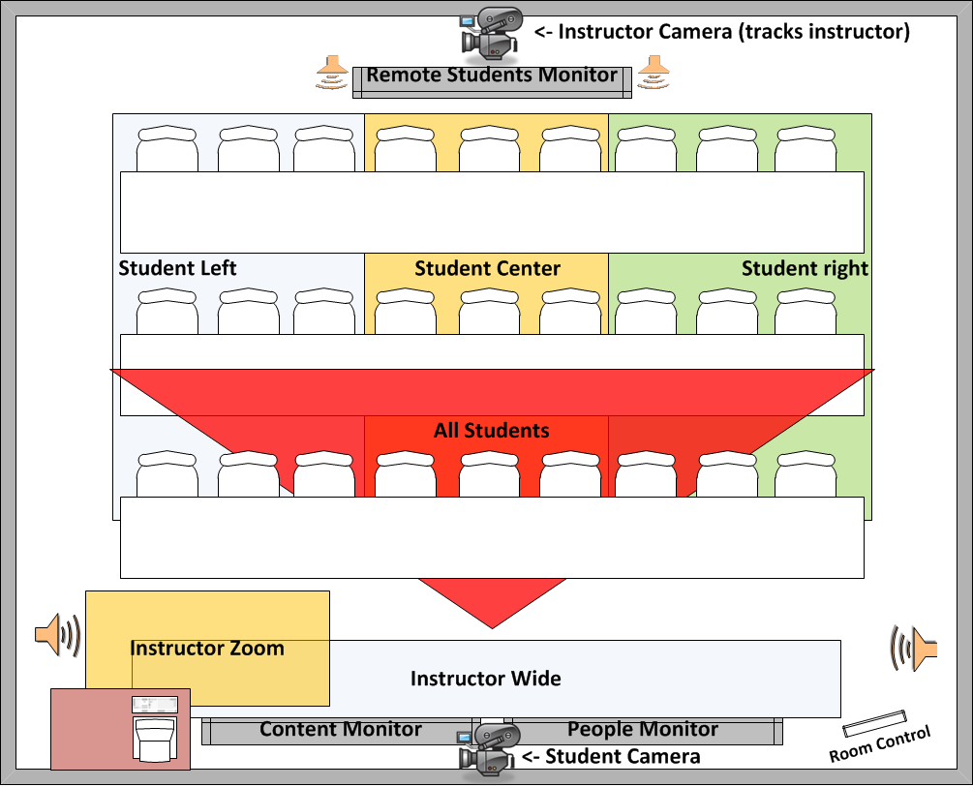

Support for:
- In class presentations (TV monitors as whiteboards or projectors)
- Multi-campus classroom sessions (connected with other multi-campus classroom or regular video conference enabled rooms)
- Individuals connecting through own device (connecting through Vidyo video conference bridge)
- Lecture broadcast to remote audience (capture through video conference setup; broadcast through Vidyo video conference bridge)
- Lecture recording (through Vidyo video conference bridge)

Multi-campus Classroom feedback

- Students agree to the pilot supporting a high level of participation and interaction across classrooms:

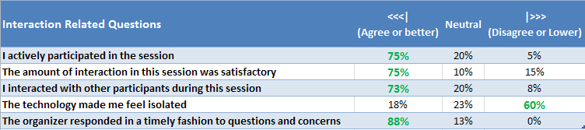

- Main student benefits of Multi-campus Classroom pilot were:
- Save travel time for students
- Able to attend courses offered at two campuses on same day

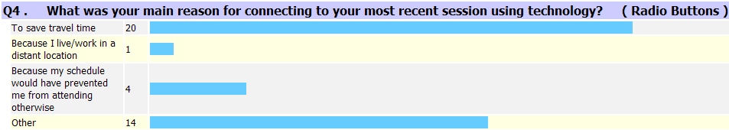

- 93% of students would consider participating in another course using the Multi-campus Classroom technology

Usage and Technology Challenges

Pictures
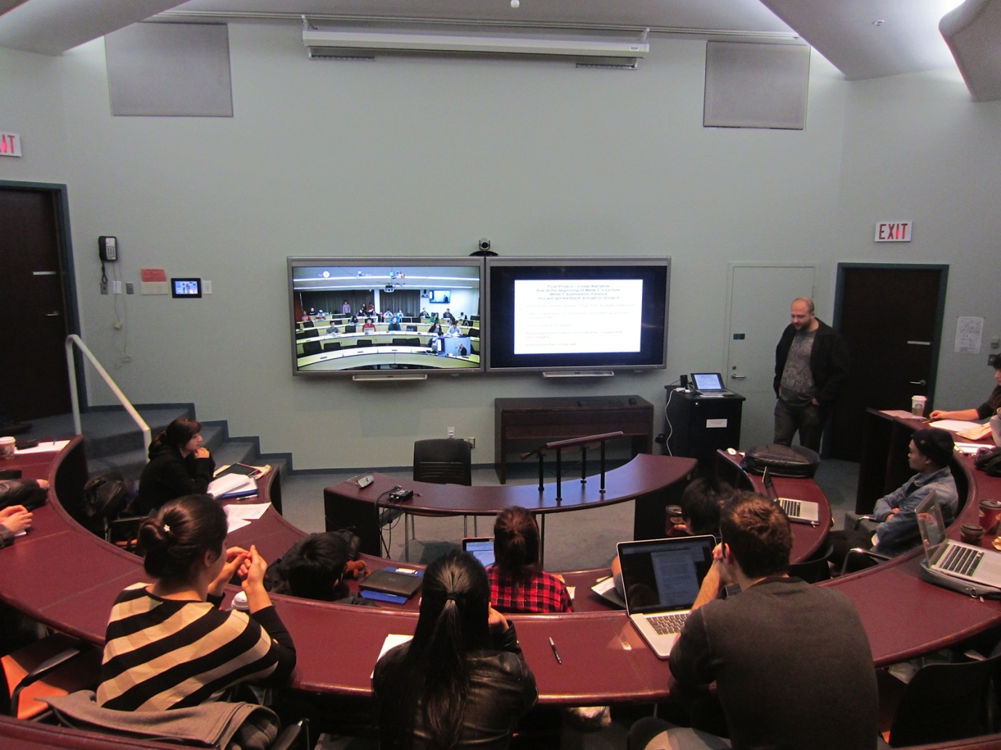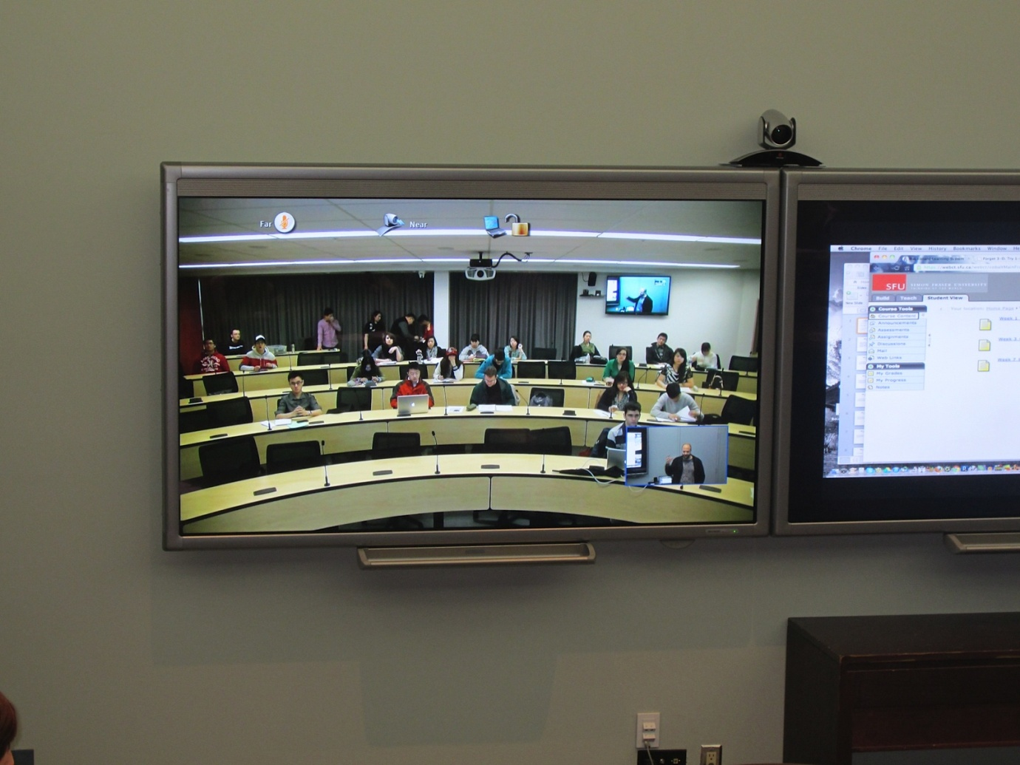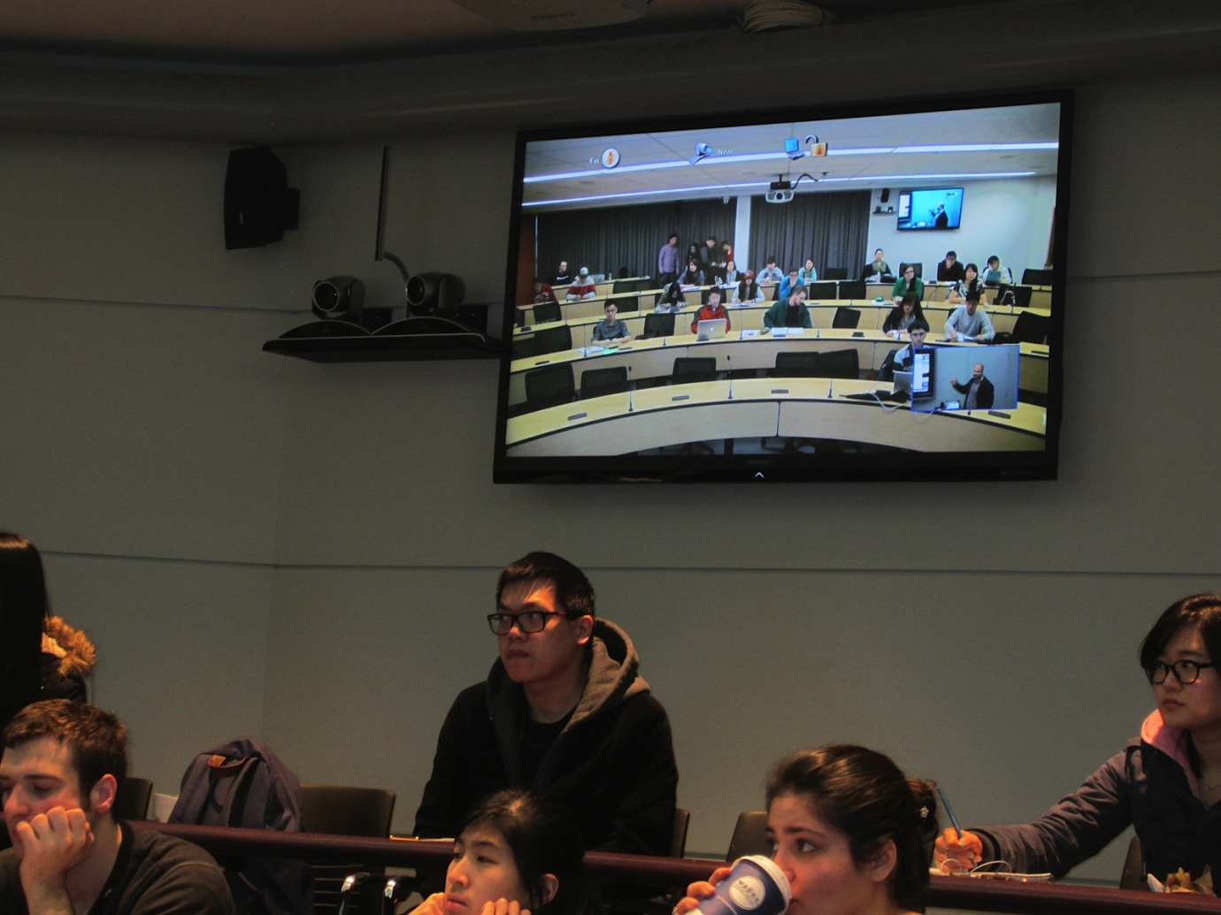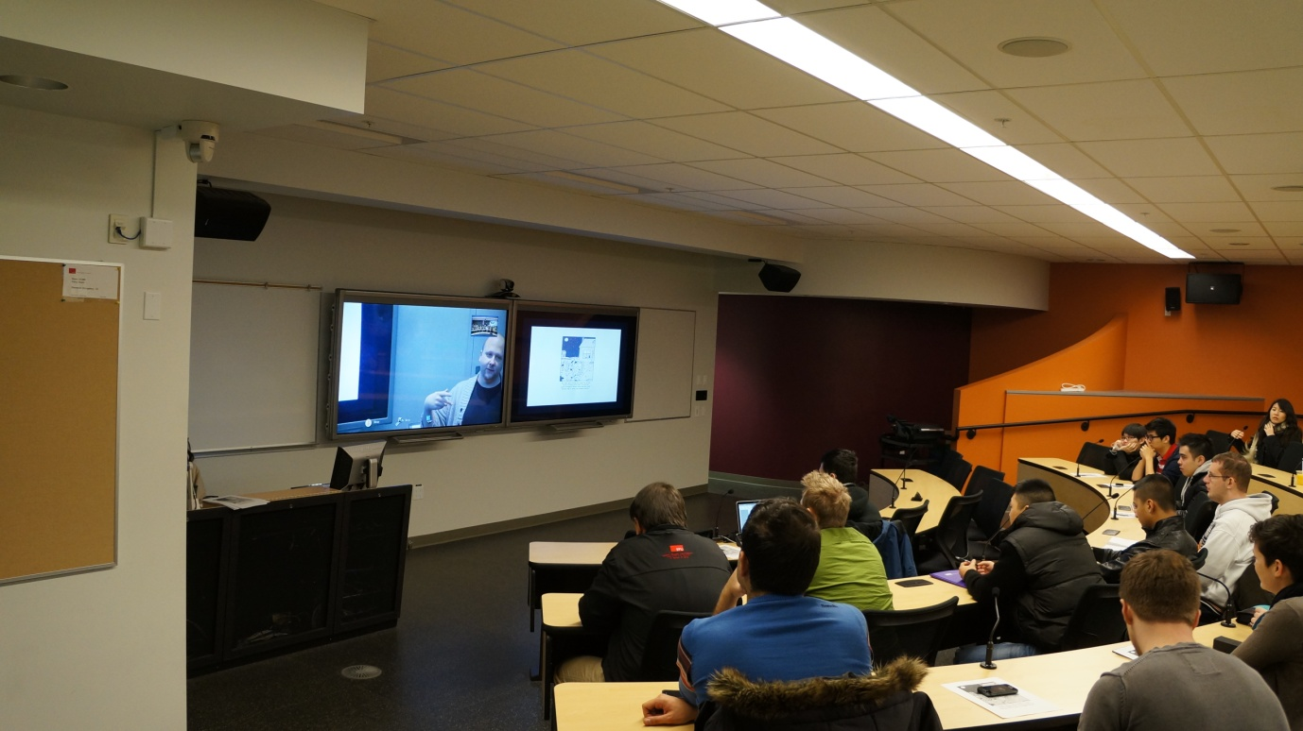

Virtual Meeting Room / Classroom Pilot

Multi-Campus Library Workshops or Administrative Meetings connecting video conference enabled meeting rooms and/or individuals connecting remotely through own device (work station, laptop, tablet, or smartphone).

- Meeting rooms and classrooms are predominately used for regular meetings or classes (not to become dedicated video conference room)
- All participants should be visible when contributing during the sessions
- Live projection of content to all participants

- Camera able to auto-track and auto-zoom to speaker is used in all rooms.

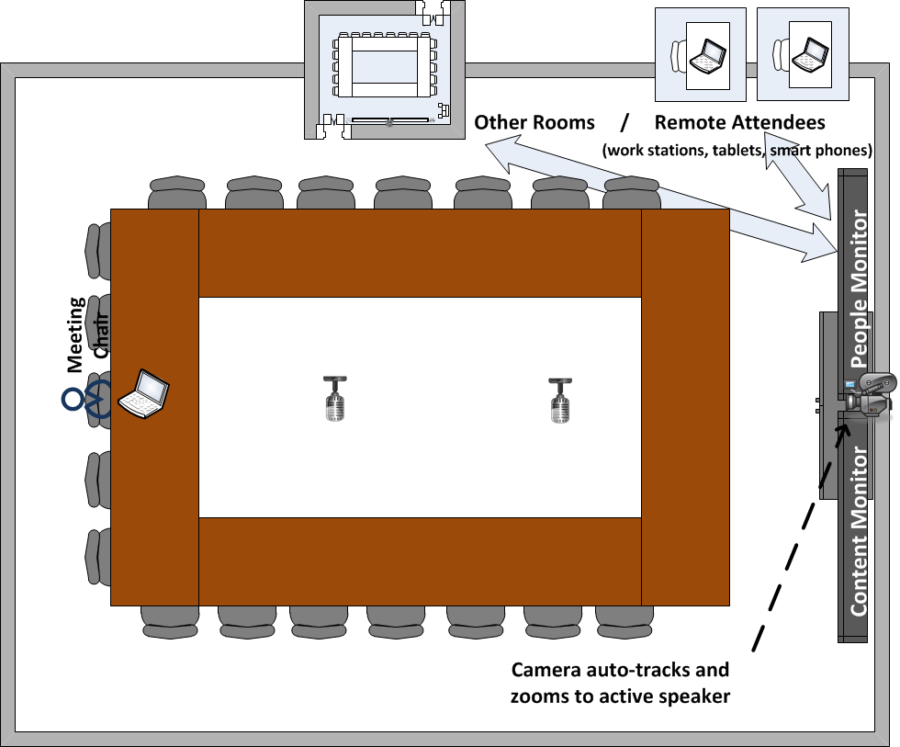

Support for
- In room/class presentations (TV monitors as whiteboards and/or projectors)
- Video conference sessions; room to room and room to individuals (connecting through Vidyo video conference bridge)
- Meeting / session recording (through Vidyo video conference bridge)

Desktop-to-Desktop Pilots

Distributed Grad Seminar
Virtual face-to-face interaction with the main objective of building relationships between the student, the mentor, and the instructor; and support high quality dialog.

Use Scenario 1: Instructor to Class Instruction and Interaction
- Full class interaction with instructor led presentations and discussions.
- Web conference type interaction - focus on presentations, document sharing and student interactions through chat

Use Scenario 2: Mentor to Student Group Break-out Sessions
- Seminar style interaction with no single participant dominating. The facilitator not necessarily the hub of the conversation.
- Video conference type interaction (video and audio) with focus on communication, expressions of opinions, establishing and building relationship among the participants

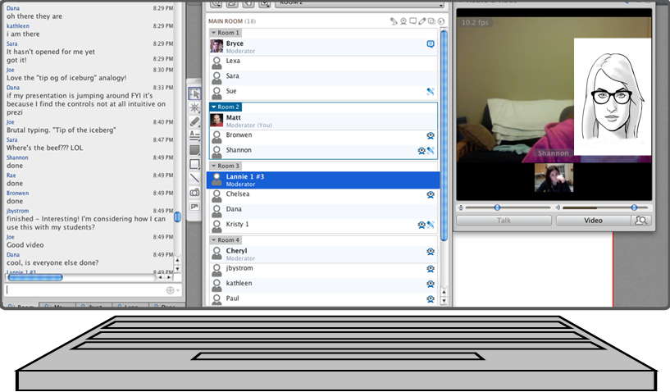

Lifelong Learning Guest Speaker Sessions
Desktop-to-Desktop scenario for a Restorative Justice session with a Guest speaker.
Provides synchronous face-to-face interaction in an otherwise a-synchronous teaching environment.

- Guest speaker will participate in a restorative justice session with an instructor being the moderator and up to 24 students
- everyone remote access through own devices
- students to contribute by comments, questions and discussion participation (video and audio presence)
- Chat functionality and Session recording supported (Through Vidyo viden conference bridge)

