The CAUs of Solid Course Design:

Maximizing Student Learning

Further Reading
- UCF’s Accessibility Tips – http://teach.ucf.edu/resources/creating-accessible-course-content/accessibility-tips.html
- CAST - http://www.cast.org/site/accessibility.html
  - Why UDL? http://www.cast.org/udl/index.html
- WebAim – http://webaim.org/
  - Wave: Web Accessibility Evaluation Tool http://wave.webaim.org/
- PennState AccessAbility: Accessibility and Usability at Penn State http://accessibility.psu.edu/accessibility
- Accessibility Tips – http://teach.ucf.edu/resources/creating-accessible-course-content/accessibility-tips.html
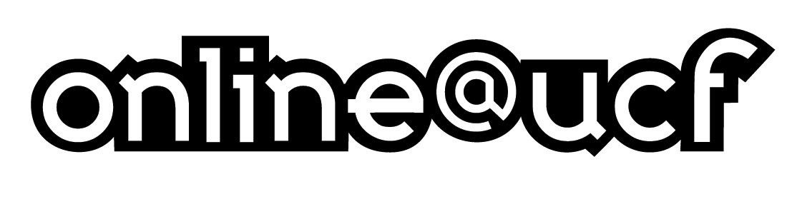
- David McCandless, The Beauty of Data Visualization http://www.ted.com/talks/david_mccandless_the_beauty_of_data_visualization.html

