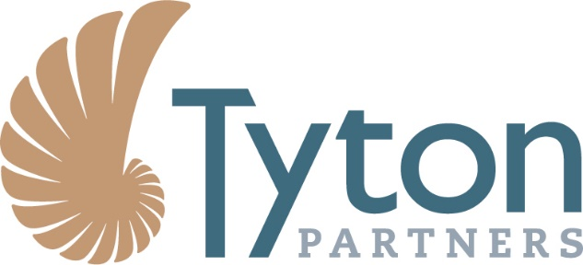

Tyton Partners Launches Largest National Study on Academic Advising and Student Success, Driving Toward a Degree 2017

PRESS RELEASES | OCT 12TH, 2017

BOSTON, MA (Oct 12, 2017) – Tyton Partners has released Driving Toward a Degree 2017, the latest report in a series that measures the extent and impact of various practices and products related to academic advising across higher education institutions nationwide. The two-part study includes survey responses from 2,200 institutional stakeholders from nearly 1,400 unique institutions, and interviews with 40+ technology providers.

For many institutions, redesign of academic advising is at the center of improving student outcomes. Key observations on the state of the field include:
- While institutional administrators report progress since Tyton Partners’ 2015 survey, only one in three reports achieving an ideal academic advising situation.
- 58% of institutions cite a high degree of clarity of ownership of advising, up from 46% in 2015, and cross-departmental collaboration has risen to 44% from 35% in 2015.
- 53% of institutions say technology effectively enhances their advising function.
- Guided pathways is growing in terms of awareness and implementation with 60% aware and 48% showing at least partial implementation.

“NACADA is proud to collaborate with Tyton Partners on the Driving Toward a Degree initiative,” said Charlie Nutt, Executive Director of NACADA – The Global Community for Academic Advising, which partnered with Tyton Partners to deliver the survey. “This initiative is a useful tool for institutions and administrators as they implement NACADA’s academic advisor competencies in pedagogy and practice. These reports do a great job in capturing the dynamics of and trade-offs between different organizational and advising models, as well as technology use.”

Tyton Partners has collaborated with a number of national organizations on this initiative, including NACADA – The Global Community for Academic Advising, Achieving the Dream, Central Carolina Community College, the National Association for College Admission Counseling (NACAC), the Reinvention Collaborative, the Community College Resource Center, and EDUCAUSE, with critical contributions from the Babson Survey Research Group. The expansive data set can enable institutional leaders to benchmark their progress on student success initiatives. For more information and to download the report, visit drivetodegree.org.

About Tyton Partners
Tyton Partners is the leading provider of investment banking and strategy consulting services to the education and global knowledge sector. Tyton offers a unique spectrum of services that supports the growth objectives for a diverse array of organizations, from emergent and established companies, to non-profit organizations, institutions, and foundations, to private equity and venture capital firms and other investors. The firm’s expertise is predicated on its principals’ years of experience working across the sector – including the preK–12, postsecondary, corporate training, and lifelong learning sectors. Visit www.tytonpartners.com for more information or follow us @tytonpartners.

About NACADA
NACADA promotes and supports quality academic advising to enhance the educational development of students at higher education institutions. NACADA provides a forum for discussion, debate, and exchange of ideas pertaining to academic advising through events and publications. NACADA has over 13,000 members including professional advisors/counselors, faculty, administrators, graduate and undergraduate students.

Media Inquiries Contact
Nicholas Java: njava@tytonpartners.com

SHARE THIS (LinkedIn – Twitter – Email)

